FAQ: Global Price Changes

| November-20 |

**Document Overview**

**Documentation Goals**

This documentation is intended to provide instruction for ***(XYZ – REPLACE WITH DOC Function)****.*

**Documentation Disclaimers**

* Teach a user how to utilize or develop in Progress.
* Provide instructions for creating or administering and Advantzware Progress Database.
* Provide application Support for other Advantzware functions.

**Special Terminology**

* ***REPLACE/LIST any special terminology for the document***

**Table of Contents**

**[Heading 1]** 3

[Heading2] 3

[Heading3] 3

# **Overview**

## Heading2

### Heading3

#### [Heading4

# **Global Quote Price Change [EG]**

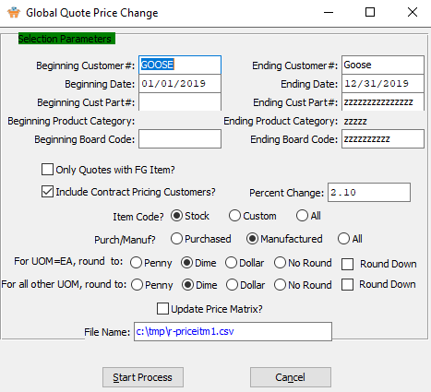

In Estimating, the *Global Quote Price Change* screen allows a user to quickly update the prices on quotes located in *Quote Maintenance [E-Q].*

## Heading2

### Heading3

#### [Heading4

# **Global Price Increase [OF4]**

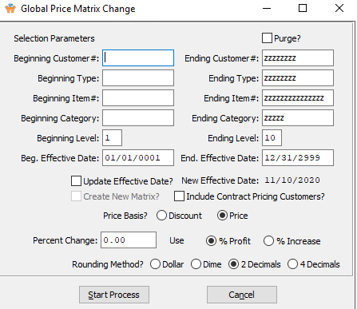

In Order Entry, the *Global Price Matrix Change* screen allows a user to quickly change the percentage rate of a price or discount for customers or items. Using this program will update the *Price Matrix* under *[O-F-3].*

## Heading2

### Heading3

#### [Heading4

# **Global Raw Material Price Change [MG]**

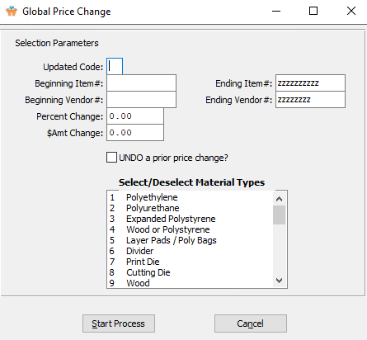

In Raw Materials, the *Global Price Change* screen allows automatic adjusting the Board Pricing under *[M-F-2]*. Select special material types for the Global Price Change feature.

## Heading2

### Heading3

#### Select/Deselect Material Types

The user may choose multiple Material Types from this list by using the ***“Control – Click”*** method. A selected Material Type will by highlighted within the list, and only highlighted Material Types will be used by the system.

# **Global Finished Good Price Change [IF6]**

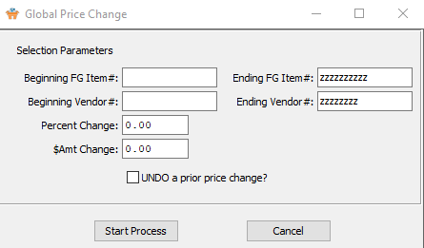

## Heading2

### Heading3

#### [Heading4